**Terraform Advanced Assessment**

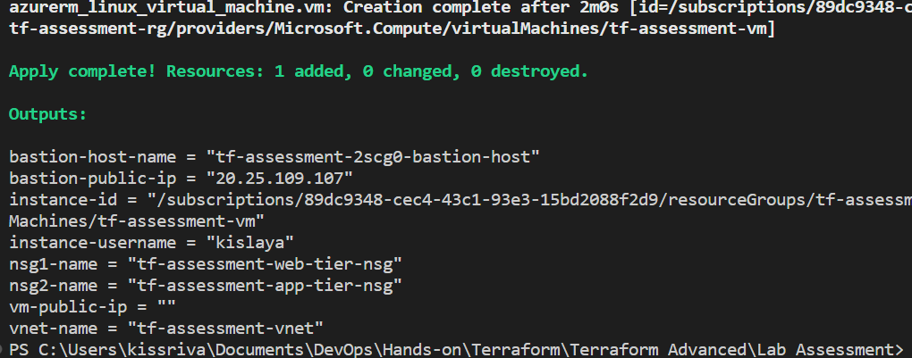

**Terraform output**

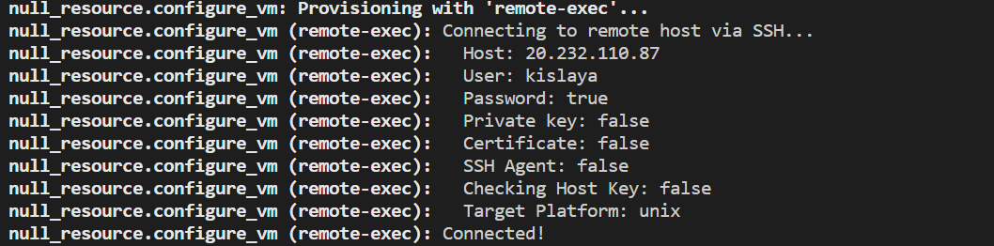

**Output of null_resource(file provisioner)**

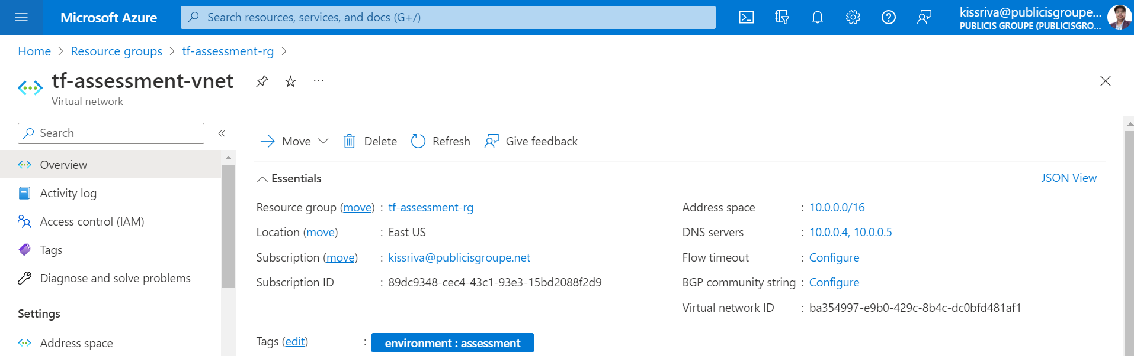

**Virtual Network Created**

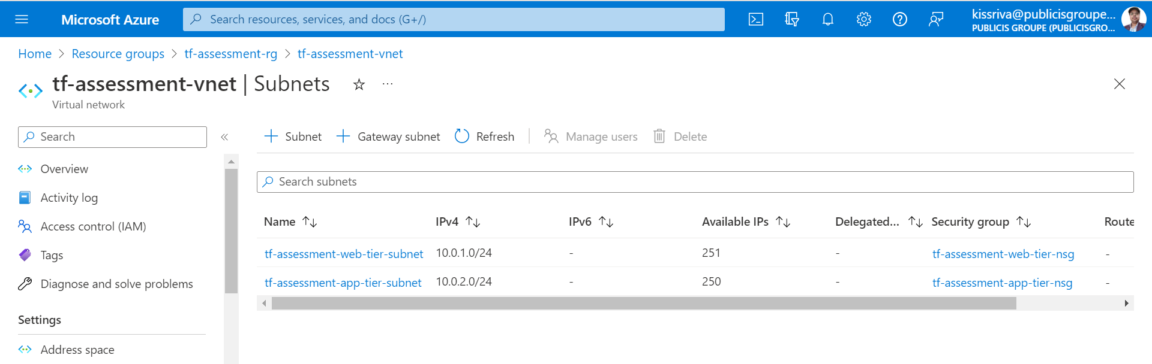

**Subnets created and linked to respective NSGs**

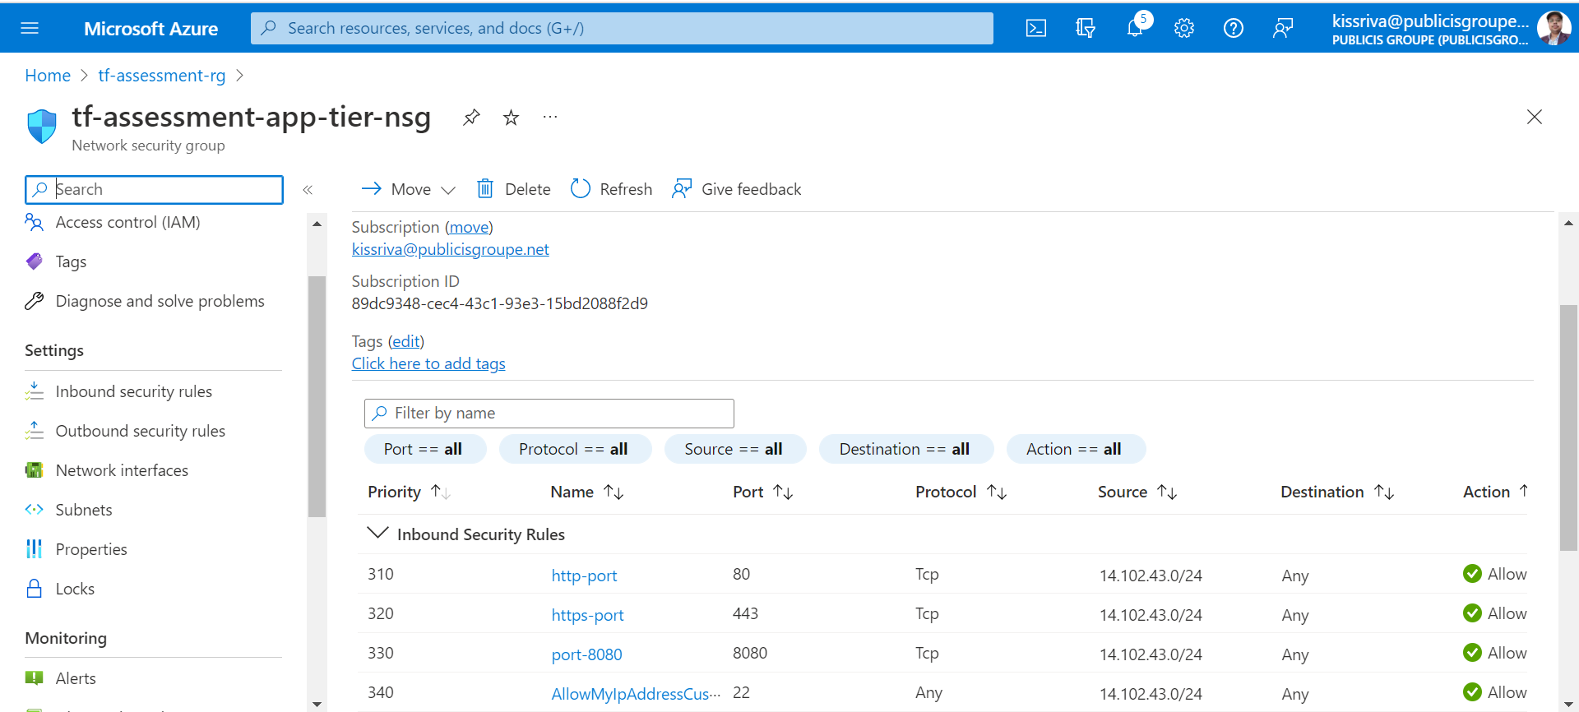

**App Tier NSG with inbound rules created**

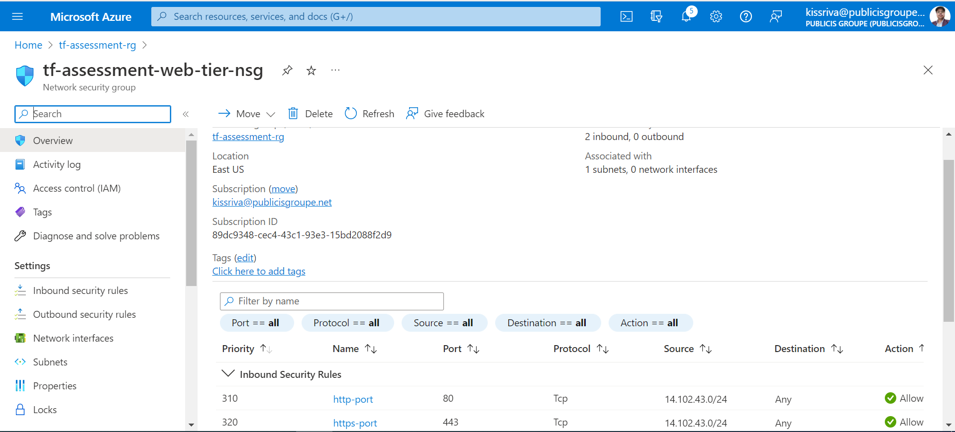

**Web Tier NSG with inbound rules created**

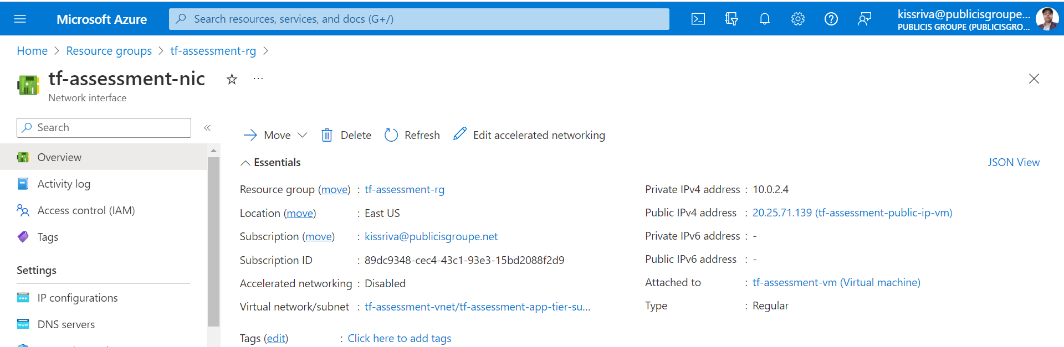

**NIC with public IP created**

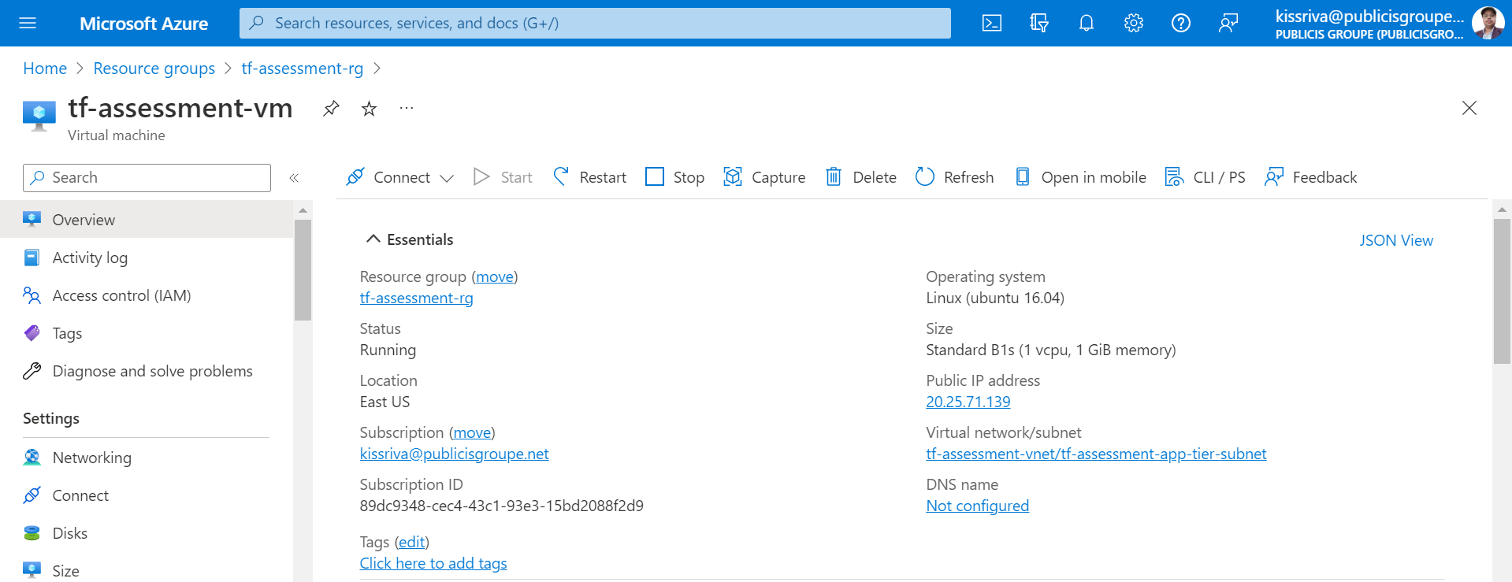

**Virtual Machine with mentioned specs created**

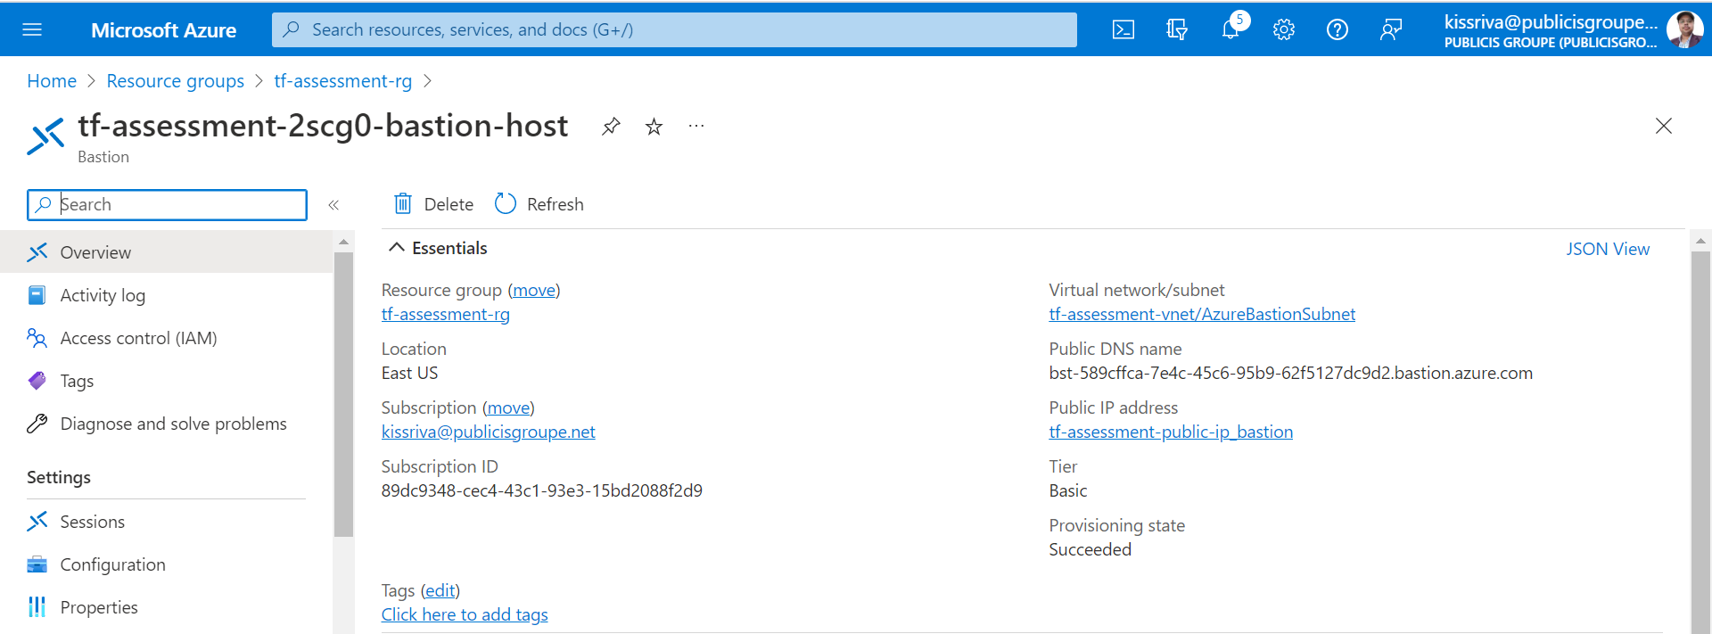

**Bastion Host Created**

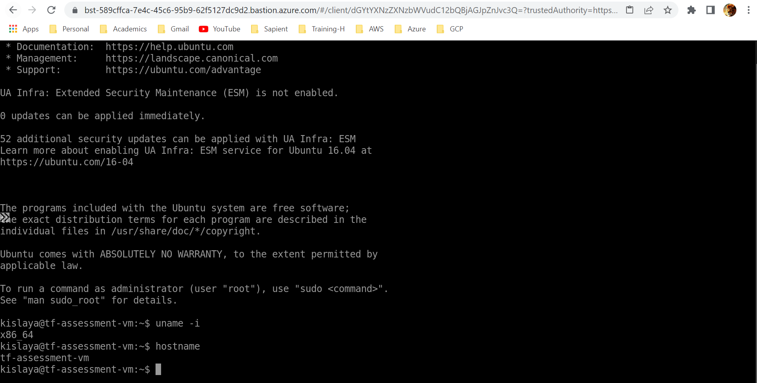

**Connected to the Virtual Machine via Bastion Host**